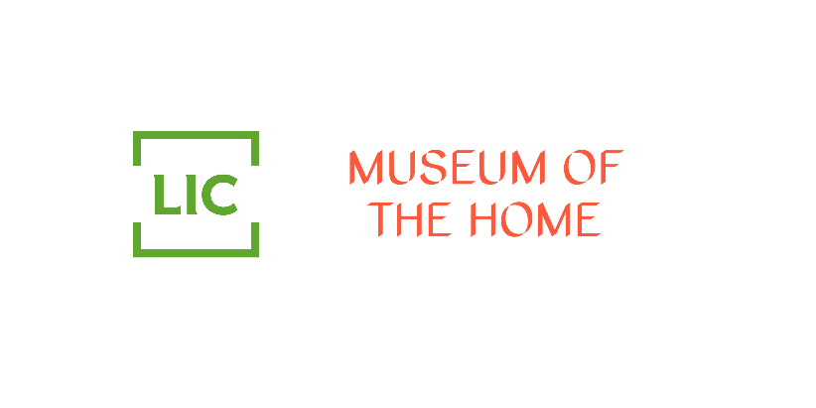

Questions for participants

On the theme of Home:
- Where do you call ‘home’?
- What was your relationship with/understanding of London before you moved here?
- When you first arrived, did you intend to stay in London/move back to Ireland/move somewhere else?
- Where did (/do) you feel most at home in London?
- Which area did you live in? What road did you live on? Which postcode did you live in?
- What sort of home did you live in (i.e. house/ maisonette/ flat etc.)?
- What decade was your home built?
- Who did you live with?
- Did this place feel like your home? OR What did you do to make this place feel like your home?
On the theme of work:
- What did you do for work?
- How did you get your job?
- How many hours did you work?
- Did you enjoy your work?
- Where did you spend your free time? What did you do?
Relationship (specific to a couple who met and married in London)*:
- How/Where did you and your partner meet?
- Did you have an engagement ring? (Maybe some questions about the proposal?)
- Where did you live when you married? Area/road/postcode
- When did you leave your first shared property? For what reason? How long had you been there?
- Did you continue to work after you were married?
- Did you maintain the same hobbies/activities?
- What did you do to make this place feel like your home?
- Where did you go out socially in London?
- What did you do to get ready to go out in London?
- Did you have a drink at home before you went out – if you did, what was it?
- Did you smoke in your home?

On the theme of London/ Ireland:
- Did you return to Ireland during the 1950s? How often did you return?
- Do you feel connected to the Irish community in London?
- Do you consider yourself/your family Irish, London Irish, or other?

On the theme of your Interior Design:

- What is the most precious object you owned in your home in the 1950s?
- What furniture did you have in your bedroom?
- What was the lighting like?
- What items did you have on display in your bedroom?
- What did the furnishings look like- the curtains/ carpet/ bed linen?
- Did you / how did you play music in your home?
- What was your favourite music- song/singer/band/radio program?
- What items did you have your bathroom?
- What clothing/shoes did you and your partner have?
- Did you have photos/picture on display in your bedroom/hallway?
- If you did, what were they of?
- Did you have any religious items in your bedroom – if you did, what were they?

